

**2017**

**BLIND FLEET RACING WORLDS**

**Hosted By:**

**Sail Sheboygan**

**Sheboygan, Wisconsin, USA**

**in conjunction with World Sailing**

**September 11-17, 2017**

**SAILING INSTRUCTIONS**

1. **Rules**
   1. The regatta will be governed by the rules as defined in The Racing Rules of Sailing.
   2. The Para World Sailing Race Management Manual (RMM) will apply.
   3. Addendum D states the US Sailing Prescriptions that will apply.
   4. If there is a conflict between languages, the English text will take precedence.

### Notice to Competitors

* 1. Notices to competitors will be posted on the official notice board.
  2. Questions concerning the notice of race, sailing instructions, scoring, or other issues shall be submitted in writing, replies will be posted in writing on the official notice board.

1. **Changes to the Sailing Instructions**
   1. Any change to the sailing instructions will be posted before 0900 on the day it will take effect.
   2. Any change to the schedule of races will be posted by 2000 on the day before it will take effect
2. **Signals made ashore**
   1. Signals made ashore will be displayed from the Sheboygan Yacht Club flag pole.
   2. When flag AP is displayed ashore, ‘1 minute’ is replaced with ‘not less than 60 minutes’ in the RRS Race Signal AP.
3. **Schedule of races**
   1. Monday September 11
      1. 0900-1500 Registration and sight classification
      2. 0900-1700 Practice (practice times will be by random draw)
      3. 1730 Competitors briefing
      4. 1830 Opening Ceremony
   2. Tuesday September 12 to Sunday September 17
      1. 1000 Racing days, first warning signal each day
         * 1. Rotation schedule per Addendum E
   3. Sunday September 17
      1. 1500 No initial warning signal after this time
      2. 1800 Closing ceremony and awards
   4. Number of races to be sailed per day will be three or more at the discretion of the Race Committee. No division will sail more than 18 races. The target time for races is 30-40 minutes.
   5. For the first race of the day or after a long postponement, to alert boats that a race or sequence of races will begin soon, an orange flag will be displayed with one sound for at least five minutes before a warning signal is displayed.
4. **Supplied boats**
   1. Boats will be provided for all competitors. Bow numbers shall be used to identify boats. A draw for boats will be made at registration and a rotation shall be created from that draw with all teams rotating on a daily basis.
   2. Addendum B, Handling the Boats, lists items and actions that are prohibited, permitted and mandatory. Addendum C, Equipment List, lists all equipment that shall be onboard at all times.
   3. All equipment provided with the boat for sailing purposes shall be in the boat while afloat.
   4. Competitors shall report any damage or loss of equipment, however slight, to the race committee after finishing a race. A breakdown on the water must be brought to the attention of the race committee or a safety boat before the warning signal of the next race. Replacement of broken or damaged gear may only be made with gear sanctioned by the organizing authority.
5. **Class flags**

|  |  |
| --- | --- |
| Class | Flag |
| B1 | Numeral Pennant 1 |
| B2 | Numeral Pennant 2 |
| B3 | Numeral Pennant 3 |

1. **Racing area**
   1. The racing area will be in the open waters of Lake Michigan east of the Sheboygan Harbor.
2. **The courses**
   1. The diagram in Addendum A shows the courses, including the order in which marks are to be passed and the side on which each mark is to be left.
   2. There may be an offset mark placed after mark 1.
   3. Mark 2 will have a gate. In the event that the gate is not in place, the single leeward Mark 2 shall be left to port.
   4. The course, compass bearing and approximate distance to the first mark, and the number of legs of the course will be displayed from the race committee signal boat no later than the warning signal.
   5. Flag A displayed, with no sound, while boats are finishing means ‘No more racing today. This changes race signals.
3. **Marks**
   1. The starting mark will be a yellow tetrahedron.
   2. Marks 1 and 2 will be orange tetrahedrons.
   3. The offset mark, if used, will be white ball.
   4. New marks, as provided in instruction 12 (a), will be yellow tetrahedrons.
   5. The finishing mark will be an orange ball.
4. **The start**
   1. The starting line will be between a staff displaying an orange flag on the signal boat at the starboard end and the course side of the port end starting mark.
   2. A boat whose warning signal has not been made shall keep clear of the starting area, defined as the area extending approximately 50 feet to windward, to leeward, and to either end of the starting line.
   3. A boat starting later than four minutes after her starting signal will be scored Did Not Start without a hearing. This changes RRS A4.
5. **Change of the next leg of the course**
   1. To change the next leg of the course, the race committee will lay a new mark (or move the finishing line) and remove the original mark as soon as practicable. When in a subsequent change a new mark is replaced, it will be replaced by an original mark.
   2. Offset marks will not be set on a changed leg of the course.
6. **The finish**
   1. The finish line will be between a staff displaying a orange flag on the signal boat at the starboard end and the course side of the port end finishing mark.
7. **Time limits**
   1. The time limit for the lead boat to reach Mark 1 is 20 minutes. If no boat has passed Mark 1 within the time limit the race will be abandoned. Failure to meet target time will not be grounds for redress. This changes RRS 62.1 (a).
   2. The time limit for the lead boat to finish each race will be 60 minutes. If no boat has finished within the time limit the race will be abandoned. Boats failing to finish within 30 minutes after the first boat to finish in their fleet, will be scored Did Not Finish without a hearing. This changes RRS 35, A4 and A5.
   3. Failure to meet target time will not be grounds for redress. This changes RRS 62.1 (a).
8. **Penalty system**
   1. RRS 44.1 is changed per US Sailing prescription Appendix V.
   2. If either the Sighted Tactician or the Sighted Crew touch either the helm or the mainsheet at any time while racing, whether in an emergency or not, the boat is required to complete a One-Turn Penalty as soon as possible after the incident. Sighted tactician shall wear a red bib and the sighted crew shall wear a yellow bib provided by the OA.
   3. A boat that has taken a penalty or retired under RRS 44.1 shall complete an acknowledgment form at the Sheboygan Yacht Club within the protest time limit.
9. **Protests and requests for redress**
   1. Protest forms are available at the Race office. Protests shall be delivered there within the protest time limit.
   2. In accordance with RRS 61.3, the protest time limit is 60 minutes after the Signal Boat has docked. The same time limit applies to protests by the race committee and jury about incidents they observe in the racing area and to request redress. This changes rules RRS 62.2
   3. Notices will be posted no later than 15 minutes after the protest time limit to inform competitors of hearings in which they are parties or named as witness. Hearings will be held in the Sheboygan Yacht Club beginning at the time posted.
   4. Notices of protests by the race committee or jury will be posted to inform boats under RRS 61.1(b).
   5. Breaches of instructions 6 (c) will not be grounds for a protest by a boat. This changes RRS 60.1(a). Penalties for these breaches may be less than disqualification if the protest committee so decides.
   6. On the last scheduled day of racing a request for redress based on a protest committee decision shall be delivered no later than 30 minutes after the decision was posted. This changes RRS 62.2
   7. Decisions of the international jury will be final as provided in RRS 70.5.
10. **Scoring**
    1. Eighteen (18) races are scheduled. Five (5) races are required to be completed to constitute a series and the championship.
       1. When fewer than six (6) races have been completed, a team’s series score shall be the total of their race scores.
       2. When seven (7) to twelve (12) races have been completed, a team’s series score shall be the total of their race scores excluding their worst score.
       3. When twelve (12) to eighteen (18) have been completed, a team’s series score shall be the total of their race scores excluding their two (2) worst scores.
       4. This changes RRS A2
    2. To request correction of an alleged error in posted race of series results, a boat shall complete a Scoring Inquiry Form available at the race office.
11. **Safety regulations**
    1. Check-in: before the warning signal of her first race of each day, a boat shall pass the stern of the race committee signal boat and hail her bow number until acknowledged by the race committee. Boats not leaving the harbor for any of the day’s racing shall so inform the race committee by VHF Channel 73.
    2. A boat that retires from a race or leaves the racing area between races shall notify the race committee as soon as practicable, by either sailing by the RC and hailing or hailing on VHF radio channel 73.
12. **Replacement of crew or equipment**
    1. Substitution of competitors will not be allowed without prior written approval of the Technical Delegate in accordance with IFDS RMM Part I, 7, Change of Crew.
    2. Replacement or change in any supplied equipment will not be allowed without prior written approval of the Organizing Authority.
13. **Supplied boat breakdown**
    1. A supplied boat suffering a breakdown shall continue to race provided that doing so will not further damage the boat or endanger its crew. At completion of race, boat may signal a breakdown by displaying green flag. Time allowed for repairs will be at the discretion of the RC.
    2. Redress will not be granted if, in the opinion of the protest committee, the breakdown resulted from carelessness, poor seamanship or incompetence.
14. **Support boats**
    1. Support boats shall register with the organizing authority and shall not interfere with boats while racing.
    2. Support boats shall be marked with their national letters (minimum size 200 mm) in accordance with the table in RRS Appendix G1.1 prominently on both sides of the outside of the hull or the outboard motor casing. . Except when participating in rescue operations, Support boats shall not exceed 5 knots within 100 meters of the area where boats are racing.
15. **Official boats**
    1. Official boats will be described at the competitors briefing.
16. **Prizes**
    1. Medals will be awarded for gold, silver and bronze in each division
    2. Blind Sailing International Squadron Cup for the team event
    3. Blind Sailing International Colin Spanhake Trophy for the B1 division
    4. If a country or state enters more than one team for a division, they must nominate their trophy qualifying crews for each division in advance, latest at registration.
17. **Disclaimer of liability**
    1. Competitors participate in the regatta entirely at their own risk. See rule 4, Decision to Race. The organizing authority will not accept any liability for material damage or personal injury or death sustained in conjunction with or prior to, during, or after the regatta
18. **Photography and video rights**
    1. Competitors give absolute right and permission for any photographs or video footage taken of themselves or their competing boat to be published in any media whatsoever for editorial, commercial purposes, or to be used in press information
19. **Further information**
    1. For further information please contact:

BJ Blahnik – Event Chairman

[Bj.blahnik@gmail.com](mailto:Bj.blahnik@gmail.com)

1-920-980-6317

Rich Reichelsdorfer – PRO

[rich@marineproservice.com](mailto:rich@marineproservice.com)

1-920-889-0758

Para World Sailing Blind Fleet Racing World and International Championship

ADDENDUM A

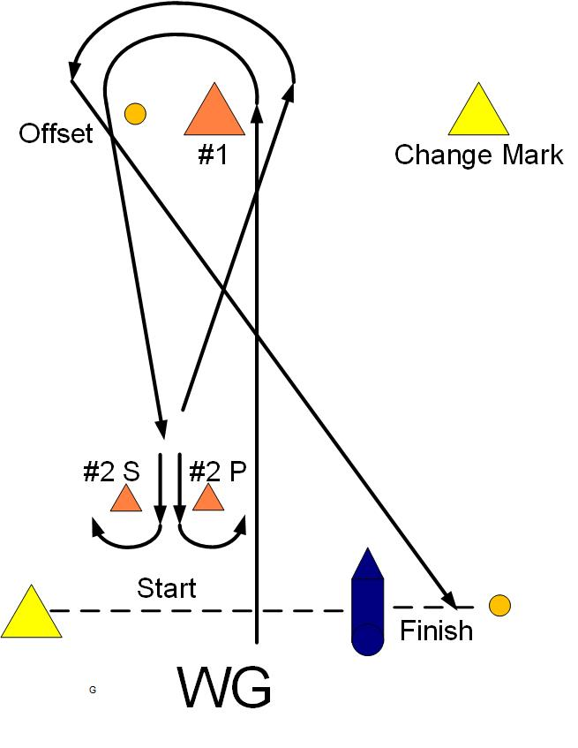

**SI ADDENDUM B - HANDLING THE BOATS**

1. **GENERAL**
   1. Reasonable steps will be taken to equalize boats. Differences among the boats shall not be grounds for redress. This changes rule 62.
   2. A boat shall not protest a breach of Addendum B. This changes rule 60.1(a).

### PROHIBITED ITEMS and ACTIONS

Except in an emergency or in order to prevent damage or injury, or when directed by a member of the race committee otherwise, the following are prohibited:

* 1. Any additions, omissions or alterations to the equipment supplied.
  2. The use of any equipment for a purpose other than that intended or specifically permitted.
  3. The replacement of any equipment without the sanction of the race committee.
  4. Sailing the boat in a manner that it is reasonable to predict that significant further damage would result.
  5. Moving equipment from its normal stowage position except when being used.
  6. Boarding a boat without prior permission.
  7. Taking a boat from its berth or mooring without having paid the required damage deposit or having permission from the race committee, or, on race days, while “AP” is displayed ashore.
  8. Hauling out a boat or cleaning surfaces below the waterline.
  9. Moving the mast blocks.
  10. Using a flattener as a reef.
  11. Perforating sails, even to attach tell tales.
  12. Adjusting or altering the tension of standing rigging, excluding the backstay.
  13. The use of electronic instruments other than compass and watches.
  14. Marking directly on the hull or deck with permanent ink.
  15. The use of the shrouds (including any inner shrouds) above the lower bottle screw (turnbuckle) to facilitate tacking or gybing, or to aid the projection of a crew member outboard is prohibited.
  16. Sitting outboard (including legs) of the toe rail is prohibited, but the upper body may lean outboard.
  17. Omitting any headsail car or turning block before sheeting.

### PERMITTED ITEMS and ACTIONS

The following are permitted:

* 1. Taking on board the following equipment:
     1. basic hand tools
     2. Electrical tape
     3. line (elastic or otherwise of 4 mm diameter or less)
     4. marking pens
     5. tell-tale material
     6. ) watch, timers and hand held compass
     7. shackles and clevis pins
     8. velcro tape
     9. spare flags
  2. Using the items in 3.1 to:
     1. prevent fouling of lines, sails and sheets
     2. attach tell tales
     3. prevent sails being damaged or falling overboard
     4. mark control settings
     5. make minor repairs and permitted adjustments
  3. Changing the number of mainsheet or jib sheet purchases.

### MANDATORY ITEMS and ACTIONS

The following are mandatory:

* 1. The completion of a written damage report before leaving a boat and submitting it to the Bosun, even if no damage or loss is recorded. Reports shall include any evidence of matters which could cause damage or disadvantage to the boat in future matches.
  2. At the end of each sailing day:
     1. mooring the boat as directed by the event bosun.
     2. rolling, bagging and placement of the sails as directed
     3. leaving the boat in the same state of cleanliness as when first boarded that day
     4. Releasing backstay tension
  3. At the end of the final day for a particular boat, cleaning the boat (cabin and decks), removing all trash and recycling and removing all tape and marks.
  4. Any request to alter, in any way, the equipment on a boat shall be in writing and worded to permit a yes/no answer.

**ADDENDUM C - EQUIPMENT LIST**

The following non-fixed items, provided by the organizing authority, are to be carried onboard at all times in their designated place while sailing. Any loss shall be reported on the daily damage report. Competitors may not protest a breach of Addendum C. This changes rule 60.1(a).

### SONARS

Mainsail and set of battens

Jib

Two Sail bags

Jib sheets

Tiller extension

Two headsail track cars

Yellow flag

*Safety Gear*

Paddle

Bucket and Sponge

Bilge Pump

Throwable cushion

Ground Tackle

Anchor

Anchor line

Moorings and Fenders

2 Dock Lines

One tow line

### ADDENDUM D – US SAILING PRESCRIPTIONS

**The following US Sailing prescriptions will apply: Rule 67 DAMAGES**

US Sailing prescribes that:

(a) A boat that retires from a race or accepts a penalty does not, by that action alone, admit liability for damages.

(b) A protest committee shall find facts and make decisions only in compliance with the rules. No protest committee or US Sailing appeal authority shall adjudicate any claim for damages. Such a claim is subject to the jurisdiction of the courts.

(c) A basic purpose of the rules is to prevent contact between boats. By participating in an event governed by the rules, a boat agrees that responsibility for damages arising from any breach of the rules shall be based on fault as determined by application of the rules, and that she shall not be governed by the legal doctrine of ‘assumption of risk’ for monetary damages resulting from contact with other boats.

### Rule 76.1 EXCLUSION OF BOATS OR COMPETITORS

US Sailing prescribes that an organizing authority or race committee shall not reject or cancel the entry of a boat or exclude a competitor eligible under the notice of race and sailing instructions for an arbitrary or capricious reason or for reason of race, color, religion, national origin, gender, sexual orientation, or age.

**Appendix V**

**V1 PENALTY AT THE TIME OF AN INCIDENT**

The first two sentences of rule 44.1 are changed to: ‘A boat may take a One-Turn Penalty when she may have broken one or more rules of Part 2 or rule 31 in an incident while *racing*. However, when she may have broken one or more rules of Part 2 while in the *zone* around a *mark* other than a starting *mark*, her penalty shall be a Two-Turns Penalty.’

**ADDENDUM E – ROTATION SCHEULDE**

|  |  |  |  |
| --- | --- | --- | --- |
| Date | Scheduled racing time 1000-1245 | 1245-1400 Team switch | Scheduled racing time 1400-1645 |
| Tuesday September 12 | B1 |  | B2 & B3 |
| Wednesday September 13 | B2 & B3 |  | B1 |
| Thursday September 14 | B1 |  | B2 & B3 |
| Friday September 15 | B2 & B3 |  | B1 |
| Saturday September 16 | B1 |  | B2 & B3 |
|  | Scheduled racing time 1000-1145 |  | Scheduled racing time 1300-1500 |
| Sunday September 17 | B2 & B3 |  | B1 |