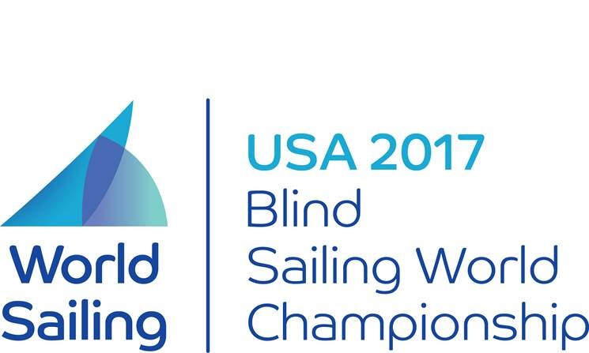

**2017**

**BLIND FLEET RACING WORLDS**

**Hosted By:**

**Sail Sheboygan**

**Sheboygan, Wisconsin, USA**

**in conjunction with World Sailing**

**September 11-17, 2017**

**Amendments to the Notice of Race and/or Sailing Instructions**

**Amendment #1**

Sailing instruction 17 is deleted and replaced with the following

**17 SCORING**

1. The low point system of RRS Appendix A will apply as amended below.
2. Five races are required to be completed to constitute a series.
3. When fewer than seven (7) races have been completed a team’s series score will be the total of their race scores.
4. When seven (7) to twelve (12) races have been completed a team’s series score will be the total of their race scores excluding their worst score.
5. When thirteen (13) or more races have been completed a team’s series score will be the total of their race scores excluding their two worst scores.
6. Nations / States entering teams in all three divisions will have their scores aggregated for the Sqaudron Cup teams event. For teams not entering all divisions the aggregated score shall include points equal to a DNS in each race for those divisions in which they are not entered.

Addendum C is changed as follows

**ADDENDUM C - EQUIPMENT LIST**

The following non-fixed items, provided by the organizing authority, are to be carried onboard at all times in their designated place while sailing. Any loss shall be reported on the daily damage report. Competitors may not protest a breach of Addendum C. This changes rule 60.1(a).

### SONARS

Mainsail and set of battens

Jib

Two Sail bags

Jib sheets

Tiller extension

Two headsail track cars

Green flag

Red flag

*Safety Gear*

Bucket and Sponge

Bilge Pump

Throwable cushion

Flares

Ground Tackle

Anchor

Anchor line

Moorings and Fenders

2 Dock Lines

Notice of Race 11.3 and SI 15 (b) are changed as follows.

Replace both NoR 11.3 and SI 15.b with the following:

If either the Sighted Tactician or the Sighted Crew breaks RMM 3.4 at anytime while racing, the boat is required to complete a One-Turn Penalty as soon as possible after the incident.

Brian Todd, TD Rich Reichelsdorfer, PRO

Posted.