Blind Fleet Racing National and
North American Championship
June 16-18, 2017
Sail Sheboygan, SEAS, and Sheboygan Yacht Club
Sheboygan, Wisconsin

SAILING INSTRUCTIONS

- RULES
1.1 The regatta will be governed by the rules as defined in The Racing Rules of Sailing.
1.2 The following US Sailing Prescriptions shall apply: RRS 61.4 Appendix R prescriptions to RRS 40, 60.3, 67, 70.5(b) and 76.1
1.3 If there is a conflict between languages the English text will take precedence.

2 NOTICES TO COMPETITORS
2.1 Notices to competitors will be posted on the official notice board located in the north dining hall windows of the Sheboygan Yacht Club.

2.2 Questions concerning the Notice of Race, Sailing Instructions, scoring, or other issues shall be submitted in writing, replies will be posted in writing on the official notice board.

3 CHANGES TO SAILING INSTRUCTIONS
Any change to the sailing instructions will be posted before 0900 on the day it will take effect, except that any change to the schedule of races will be posted by 2000 on the day before it will take effect.

4 SIGNALS MADE ASHORE
4.1 Signals made ashore will be displayed at the flagpole on the grounds between the Sheboygan Youth Sailing Club and the Sheboygan Yacht Club overlooking the floating docks.
4.2 When flag AP is displayed ashore, ‘1 minute’ is replaced with ‘not less than 45 minutes’ in the race signal AP.

5 SCHEDULE OF RACES
5.1 Racing will take place on June 16th, 17th and 18th.

5.2 Thursday, June 15
1000-1600 Registration Sheboygan Yacht Club(SYC)
1200-1700 Practice Sail Sheboygan Trailer
1800 Opening Ceremony SYC

Friday, June 16
0900 Competitors Meeting SYC Pavilion
1055 First Warning

Saturday, June 17
0900 Competitors Meeting SYC Pavilion
1055 First Warning
1800 Social Dinner (to be announced) SYC

Sunday, June 18
0900 Competitors Meeting SYC Pavilion
1055 First Warning
1400 No warning after this time
1700 Awards SYC Pavilion

5.3 The number of races per day will vary depending on conditions. It is the intension of the race committee to race as many as possible each day
5.4 To alert boats that a race or sequence of races will begin soon, the orange starting line flag will be displayed with one sound at least five minutes before a warning signal is made.
5.5 On the last day of the regatta no warning signal will be made after 1400.

6 CLASS FLAGS
The class flag shall be the numeral pennant 1.

7 SUPPLIED BOATS
7.1 Boats will be provided for all competitors. Hull numbers shall be used to identify boats. A draw for boats will be made at Registration and a rotation shall be created from that draw with each team rotating up one number each day.

7.2 Addendum B, Boats provided by the Organizing Authority, lists items and actions that are prohibited, permitted and mandatory.

7.3 All equipment provided with the boats for sailing purposes shall be in the boat while afloat.

7.4 Competitors shall report any damage or loss of equipment, however slight, to the race committee after finishing a race. A breakdown on the water must be brought to the attention of the race committee or a safety boat before the warning signal of the next race. Replacement of broken or damaged gear may only be made with gear sanctioned by the organizing authority.

8 RACING AREAS
The racing area shall be the waters of Lake Michigan near the Sheboygan harbour entrance.

9 THE COURSES
9.1 The diagrams in Addendum A show the courses, including the order in which marks are to be passed, and the side on which each mark is to be left.
9.2 The course, compass bearing, approximate distance to the first mark, and the number of legs shall be displayed from the race committee signal boat no later than the warning signal.
9.3 Flag A displayed, with no sound, while boats are finishing shall indicate “No more racing today.” This changes the race signals.

10 MARKS
10.1 The original windward mark shall be a red and white cylinder, the original leeward mark shall be a blue and white cylinder.

10.2 The original windward and leeward marks may provide audio assistance to competitors. The absence of the audible sound shall not be grounds for protest.

10.3 New marks, as provided in instruction 12, will be orange tetrahedrons.

11 THE START
11.1 Races will be started by using rule 26 with the warning signal made 5 minutes before the starting signal.

11.2 The starting line will be between a staff displaying an orange flag on the signal boat and the course side of the port end starting mark.
11.3 A boat starting later than 4 minutes after her starting signal will be scored Did Not Start without a hearing. This changes rule A4.
11.4 If any part of a boat’s hull, crew or equipment is on the course side of the starting line during the two minutes before her starting signal and she is identified, the race committee will attempt to broadcast her sail number on VHF channel 72. Failure to make a broadcast or to time it accurately will not be grounds for a request for redress. This changes rule 62.1(a).

12 CHANGE OF THE NEXT LEG OF THE COURSE
To change the next leg of the course, the race committee will lay a new mark (or move the finishing line) and remove the original mark as soon as practicable. When in a subsequent change a new mark is replaced, it will be replaced by an original mark.

13 THE FINISH
13.1 The finishing line will between an orange flag on the committee boat and a nearby mark.
13.2 If a finishing mark is missing but another one remains in place, the finishing line is a line through the remaining mark at a 90° angle to the last leg and of the shortest practicable length. If the race committee is absent when a boat finishes, she should report to the race committee her finishing time and her position in relation to nearby boats at the first reasonable opportunity.

14 PENALTY SYSTEM
14.1 Rule 44.1 is changed so that the Two-Turns Penalty is replaced by the One-Turn Penalty.
14.2 If either the Sighted Tactician or Sighted Crew touch either the helm or the mainsheet at any time while racing, whether in an emergency or not, the boat is required to complete a One-Turn Penalty as soon as possible after the incident.

15 TIME LIMITS AND TARGET TIMES
15.1 The time limit for the lead boat to reach Mark 1 is 20 minutes. If no boat has passed Mark 1 within the Mark 1 time limit the race will be abandoned.
15.2 Boats failing to finish within 30 minutes after the first boat sails the course and finishes will be scored Did Not Finish without a hearing. This changes rules 35, A4 and A5.
15.3 The time limited for the lead boat to finish the race will be 90 minutes. If the lead boat has not finished within the time limit the race will be abandoned.

16 PROTESTS AND REQUESTS FOR REDRESS
16.1 Protest forms are available at the Race Office. Protests shall be delivered there within the protest time limit.

16.2 In accordance with rule 61.3, the protest time limit is 60 minutes after the Signal Boat has docked. The same time limit applies to protests by the Race Committee and Jury about incidents they observe in the racing area and to request redress. This changes rules 61.3 and 62.2.

16.3 Notices will be posted no later than 15 minutes after the protest time limit to inform competitors of hearings in which they are parties or named as witness. Hearings will be held in the race office in the Sheboygan Yacht Club, beginning at the time posted.

16.4 Notices of protests by the Race Committee or Jury will be posted to inform boats under rule 61.1(b).

17 SCORING
17.1 The scoring system will be according to RRS Appendix A.

17.2 If 5 or more races are completed the lowest score will be thrown-out.

17.3 Score for the Championships shall be kept as a combined fleet.

17.4 Score will also be kept in three classes: Class B1, Class B2, and Class B3.
(a) Class B1 teams will comprise of:
- a B1 Helmsperson
- a B1 or B2 Mainsheet Trimmer
- a Sighted Tactician who shall not handle any controls at any time while racing
- a Sighted Crew who may handle all controls with the exception of the Helm, the Mainsheet, and the Mainsheet Traveler
(b) Class B2 teams will comprise of:
- a B1 or B2 Helmsperson
- a B1, B2, or B3 Mainsheet Trimmer
- a Sighted Tactician who shall not handle any controls at any time while racing
- a Sighted Crew who may handle all controls with the exception of the Helm, the Mainsheet, and the Mainsheet Traveler
(c) Class B3 teams will comprise of:
- a B1, B2, or B3 Helmsperson
- a B1, B2, or B3 Mainsheet Trimmer
- a Sighted Tactician who shall not handle any controls at any time while racing
- a Sighted Crew who may handle all controls with the exception of the Helm, the Mainsheet, and the Mainsheet Traveler

18 SAFETY REGULATIONS
18.1 Check-In: prior to the warning signal of her first race of each day, a boat shall pass the race committee signal boat and hail her boat number until acknowledged by the race committee. Boats not leaving the harbor for any of the day’s racing shall so inform the race committee, by VHF Channel 72.
18.2 A boat that retires from a race or leaves the racing area shall notify the race committee as soon as possible by signalling or hailing on VHF radio channel 72.
18.3 Competitors shall wear a personal flotation device (PFD) approved by the US Coast Guard, properly secured while launching and from the time a boat leaves the dock until she returns to the dock, except while adding or removing clothing.

19 REPLACEMENT OF CREW OR EQUIPMENT
Substitution of competitors will not be allowed without prior written approval of the Organizing Authority.

20 Supplied Boat Breakdown
20.1 A supplied boat suffering a breakdown shall continue to race provided that doing so will not further damage the boat or endanger its crew. At completion of the race the boat may signal a breakdown by displaying a GREEN flag. Time allowed for repairs will be at the discretion of the Race Committee.

20.2 Redress will not be granted if, in the opinion of the protest committee, the breakdown resulted from carelessness, poor seamanship or incompetence.

21 EVENT ADVERTISING
Boats may be required to display event advertising supplied by the organizing.

22 SUPPORT BOATS
22.1 Support boats shall register with the organizing authority and shall not interfere with boats while racing.

22.2 Team leaders, coaches and other support personnel shall stay outside areas where boats are racing from the time of the preparatory signal for the first class to start until all boats have finished or retired or the race committee signals a postponement, general recall or abandonment.

23 RADIO COMMUNICATION
Except in an emergency, a boat shall neither make radio transmissions while racing nor receive radio communications not available to all boats. This restriction also applies to mobile telephones.

24 PRIZES
Prizes will be awarded as described in the Notice of Race.

25 DISCLAIMER OF LIABILITY
Competitors participate in the regatta entirely at their own risk. See rule 4, Decision to Race. The organizing authority will not accept any liability for material damage or personal injury or death sustained in conjunction with or prior to, during, or after the regatta.

26 PHOTOGRAPHY AND VIDEO RIGHTS
Competitors give absolute right and permission for any photographs or video footage taken of themselves or their competing boat to be published in any media whatsoever for editorial, commercial purposes, or to be used in press information.

27 FURTHER INFORMATION
For further information please contact:
Matt Wierzbach
Regatta Chairman
mattw@seasheboygan.org
(920)918-9204
Regatta website: http://www.sailsheboygan.org/events/2017blind-fleet/
ADDENDUM A
Course Diagrams

W-3 W-4
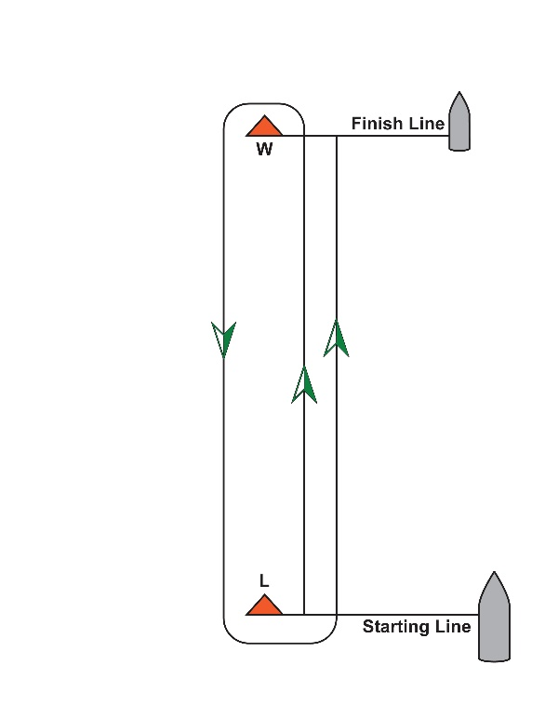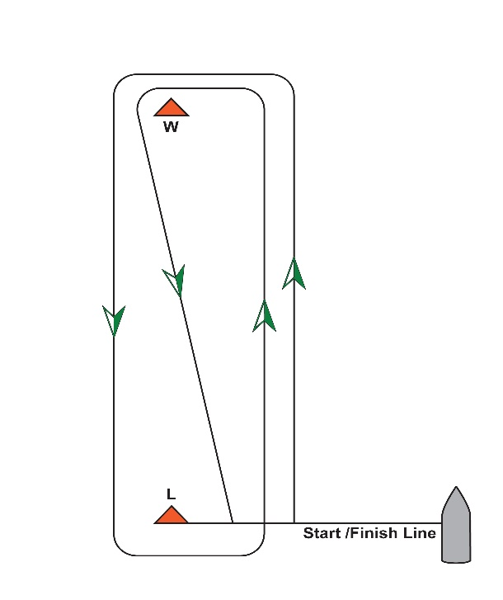

W–5
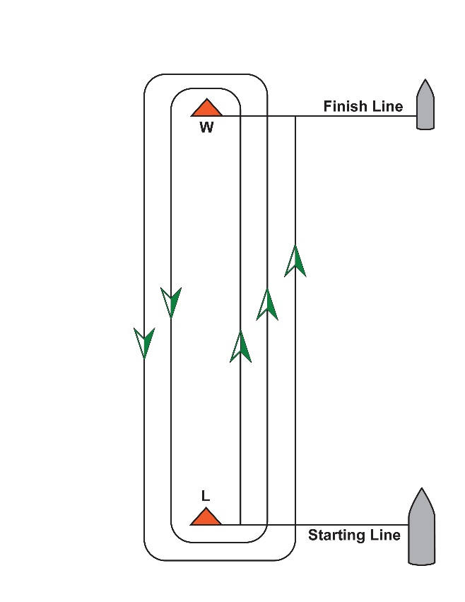
ADDENDUM B
BOATS PROVIDED BY THE ORGANIZING AUTHORITY

1 GENERAL
Reasonable steps will be taken to equalize boats. Differences among the boats shall not be grounds for redress. This changes rule 62.
2 PROHIBITED ITEMS AND ACTIONS
Except in an emergency or in order to prevent damage or injury, or when directed by a member of the race committee otherwise, the following are prohibited:
2.1 Any additions, omissions or alterations to the equipment supplied.
2.2 The use of any equipment for a purpose other than that intended or specifically permitted.
2.3 The replacement of any equipment without the sanction of the race committee.
2.4 Sailing the boat in a manner that it is reasonable to predict that significant further damage would result.
2.5 Moving equipment from its normal stowage position except when being used.
2.6 Boarding a boat without prior permission.
2.7 Taking a boat from its berth without having paid the required damage deposit or having permission from the Race Committee, or, on race days while “AP” is displayed ashore.
2.8 Hauling out a boat or cleaning surfaces below the waterline.
2.9 Moving the mast blocks.
2.10 Using a flattener as a reef.
2.11 Perforating sails, even to attach tell tales.
2.12 Adjusting or altering the tension of standing rigging, excluding the backstay.
2.13 The use of electronic instruments other than compass, watches, or VHF.
2.14 Marking directly on the hull or deck with permanent ink.
2.15 The use of the shrouds (including any inner shrouds) above the lower turnbuckle to facilitate tacking or gybing, or to aid the projection of a crew member outboard is prohibited.
2.16 Sitting outboard (including legs) of the toe rail is prohibited, but the upper body may lean outboard.
2.17 The use of “Duct tape” on any component of the boat.
3 PERMITTED ITEMS AND ACTIONS
The following are permitted:
3.1 Taking on board the following equipment:
(a) Basic hand tools
(b) Electrical tape
(c) Line, 4 mm diameter or less
(d) Tell-tale material
(e) Watch, timers, hand held or portable compass
3.2 Using the items in 3.1 to:
(a) Prevent fouling of lines, sails and sheets
(b) Attach tell-tales
(c) Prevent sails being damaged or falling overboard
(d) Mark control settings
4 MANDITORY ITEMS AND ACTIONS
4.1 Reporting damage to the Race Committee or Bosun.
4.2 At the end of each sailing day:
(a) Mooring the boat as directed by SEAS/Sail Sheboygan.
(b) Rolling, bagging, and placing sails in the storage trailer
(c) Leaving the boat in the same state of cleanliness as when first boarded that day
(d) Releasing backstay tension
4.3 Remove all trash and recycling as well as tape and markings from the boat.
4.4 Any request to alter, in any way, the equipment on a boat shall be in writing and worded to permit a yes/no answer.
4.5 A sighted crew MUST helm the boat within the confines of the Sheboygan Harbor, this includes:
(a) Leaving the dock
(b) Sailing through the rock cut
(c) Sailing in the outer harbor
(d) Docking

ADDENDUM C
Sonar Equipment List
Mainsail and set of battens
Jib
Two sail bags
Jib Sheet
Tiller extension
Green Flag
Bucket and Sponge
Pump
Throw able cushion
Anchor and rode
Dock lines (2)
Fender

