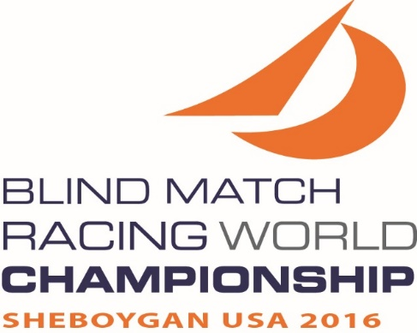

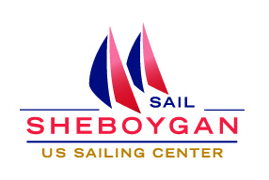

**2016**

**WORLD SAILING**

**Blind Match Racing World Championship**

**Sheboygan, WI, USA**

**19– 25 September 2016**

EVENT INFORMATION

**Hosted by Sail Sheboygan and Sheboygan Yacht Club**

On behalf of Sail Sheboygan and Sheboygan Yacht Club, it is our pleasure to inform you of the 2016 Blind Match Racing World Championship. The event will take place in Sheboygan, Wisconsin, USA from Monday September 19 through Sunday September 25, 2016. The Notice of Race may be found on the Sail Sheboygan website at: <http://www.sailsheboygan.org/2016-blind-match-racing/> . The regatta is limited to two teams from each nation. The host nation is allowed up to 4 additional teams for a total of 6 teams.

**Advanced Blind Match Racing Clinic with Dave Perry**

Sail Sheboygan will be hosting an Advanced Blind Match Racing Clinic with Dave Perry, from September 14 to 16. All teams are invited to the clinic. The cost of the clinic is TBA.

**Registration**

The Race Office, located at the Sheboygan Yacht Club, will be open for registration and weighing Monday, September 19 from 1000 to 1700 CDT. The event registration fee is $1250.00. Damage deposit of $500 US must be paid before a boat assignment will be made. Payments can be made by cash, check or credit card.

**Practice**

The Sonar’s will be available for practice, Monday, September 19 from 1200 to 1700 and Tuesday, September 20 from 1000 to 1500. Practice shall be only during specified practice times. Competitors must complete all registration requirements, pay all fees, and provide a damage deposit before being assigned a boat for practice.

**Ophthalmological examinations**

Examinations will be conducted for those who need to be classified on Monday, September 19 from 1000 to 1800.

**Daily Briefing**

Daily briefing will be at 0800 at Sheboygan Yacht Club on racing days.

**Racing**

Racing days will be Wednesday September 21 through Sunday September 25, 2016. A combination of Round Robins and Knock-out matches is planned to maximize racing for all competitors.

**Meals**

Breakfast and lunch will be provided from multiple area Lions Clubs.

**Social Schedule**

* September 20 – 1800 - Opening Ceremony followed by a dinner. The dress attire will be sailor casual.
* September 23 – 1800 – Brat Fry and Fireworks
* September 25 – after racing is concluded – Closing Ceremony and Awards Presentation Dinner.

**Lodging**

Lodging within walking distance of the Sail Sheboygan facilities include:

* Grand Stay Hotel [www.grandstaysheboygan.com](http://www.grandstaysheboygan.com)

Grand Stay Hotel is offering a special rate for 8 night stay (Sun. Sept. 18 – Mon. Sept. 26). $639.20 for the week per room (Rooms have one queen bed and pull-out sofa). Reservations must be made by Aug. 18, 2016. Reservation code: World Sailing Championship. 17 rooms available – first come, first serve. Call +1 920.208.8000 to make reservation.

* Blue Harbor Resort, Villas and Water-park [www.blueharborresort.com](http://www.blueharborresort.com)

Additional hotels and information can be found at [www.visitsheboygan.com/stay/lodging](http://www.visitsheboygan.com/stay/lodging).

Upon request and availability, housing may be provided to competitors in private homes of Sheboygan area residents.

**Transportation**

Milwaukee General Mitchell Airport (MKE) and Chicago O’Hare International Airport (ORD) serve the area. Milwaukee is approximately a 1 hour drive from Sheboygan. Chicago ORD is approximately a 2 ½ hours drive from Sheboygan. Airport Limousine and shuttle services are readily available to both Milwaukee and Sheboygan. Wisconsin Coach Lines operates an hourly bus service between ORD and MKE. Information regarding schedules and costs can be found at: <http://www.coachusa.com/wisconsincoach/ss.ohareairport.asp> Go Riteway provides airport shuttle services from both MKE and ORD to Sheboygan. Visit http://goriteway.com/ for information.

**Weather**

Links for local weather can be found on our website or at the following [www.sailsheboygan.org/?page_id=109](http://www.sailsheboygan.org/?page_id=109) The Lake Michigan water temperature is approximately 15 to 20 degrees cooler than air temperature this time of year. This temperature difference helps to provide dependable breezes, but you may find you need additional clothing layers.

**Confirm Acceptance**

Please note that in order to remain eligible, you are required to confirm your acceptance to Rich Reichelsdorfer via e-mail at [rich@windway.com](mailto:rich@windway.com)  and pay the non-refundable entry bond of $250 (US dollars) by August 15th, 2016. Payment may be made via PayPal or check.

**Information**

Contact Rich Reichelsdorfer [rich@windway.com](mailto:rich@windway.com) for more information.

We look forward to your response,

Sail Sheboygan

P.O. Box 649

Sheboygan, WI 53082-0649

+1 (920)-889-0758

**Blind Match Racing World Championship 2016**

**Sheboygan, WI, USA**

**September 19-25, 2016**

**ENTRY FORM**

|  |  |  |  |  |  |
| --- | --- | --- | --- | --- | --- |
| Helmsman – Skipper: | | | Birth date: | | Country: |
| Address: | | | Post Code: | | City, State: |
| Telephone: | Fax: | | Email: | | |
| Sailing Club: | | | SNA Card: | | IFDS Card: |
| IBSA: B1 B2 B3 | | Points: ____________ | | F  M | World Sailing  Sailor ID: |

**CREW LIST**

|  |  |  |  |  |  |
| --- | --- | --- | --- | --- | --- |
| Full name/surname | Birth date | Nationality |  | IBSA / Points | SNA / ID |
| Crew 1: |  |  | F  M |  |  |
|  |
| Crew 2: |  |  | F  M |  |  |
|  |
| Reserve: |  |  | F  M  Total points: |  |  |
|  |

I am aware that the team shall be comprised per part 4 of the Para World Sailing Race Management

Manual as updated January 2016.

Entry fee of USD $1250 can be made via US Check or by credit card through Pay Pal. A separate

damage deposit of USD $500 made payable to Sail Sheboygan will be required at registration.

I agree to be bound by the Racing Rules of Sailing, the Sailing Instructions, the Rules and Bylaws of

the Host Club, and all other rules that govern this event including the Disclaimer of Liability in the

Notice of Race, which excludes our right to claim compensation in certain circumstances.

If you are Under 18, please send your entry with the Parent/Guardian Declaration form and ask them

to countersign your entry form.

Date: _______ / _______ / 2016 Signature: ______________________________________

***PLEASE BE AWARE THAT TEAMS THAT WITHDRAW FROM AN EVENT WILL BE CHARGED IF NO OTHER SUBSTITUTE TEAM CAN BE FOUND. ENTRY FEES SHOULD BE SENT TO: SAIL SHEBOYGAN, P.O. BOX 649, SHEBOYGAN, WI 53082-0649, U.S.A., EMAILED TO*** [***rich@windway.com***](mailto:rich@windway.com) ***OR ONLINE AT*** [***http://www.sailsheboygan.org/2016-blind-match-racing***](http://www.sailsheboygan.org/2016-blind-match-racing)

***ENTRIES AND PAYMENT MUST BE RECEIVED BY AUGUST 15, 2016 AT 2359 LOCAL TIME (GMT -5 HOURS). PAYMENT BY CREDIT/DEBIT CARD: VISA / MASTERCARD ON THE EVENT WEBSITE.***